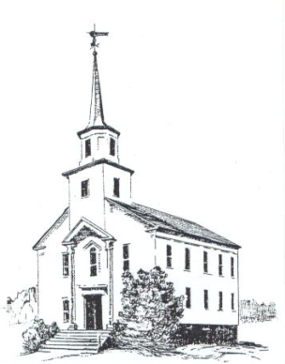The United Church of Hinesburg
P.O. Box 39
Hinesburg, VT 05461
Office: 802-482-3352 - unitedchurch@gmavt.net
Web Address: ucofh.org

From the United Church of Hinesburg Auxiliary:

We understand that your family has experienced a profound loss. We extend to you our condolences.

The members of our church Auxiliary want to support you and your family in your bereavement.

Here is what we can offer:
If you are a member of the United Church of Hinesburg then you may have talked with our pastor and know that the church facilities at Osborne Parish House are available to you.

Or, as a non-member you may have contracted to use our facilities.

The Auxiliary can help with a reception at the hall for your family. Our members provide a set-up with tablecloths, napkins, beverages, finger sandwiches and desserts, service and cleanup.

Although we do not charge a fee for our services, a donation to the Auxiliary is appropriate and reflects the number of people attending and your family's means. These donations may range from $50.00 to $100.00 or $150.00 depending on the situation. Checks may be made out to: United Church of Hinesburg Auxiliary.

Please contact the church administrative assistant at 802-482-3352 to make arrangements.

Your family is part of our greater family and we sympathize with your loss.

