2019 HYP Middle School Youth Trip

Background
Every summer, high school youth from Hinesburg travel for a time of service, education and fun. In previous years, this group has explored food insecurity in New York City, social justice issues in Boston, Massachusetts and disaster cleanup in Puerto Rico. This program, called the Hinesburg Youth Project (HYP) is a non-denominational/interfaith/no-faith inclusive program of the United Church of Hinesburg and is open to youth grades 8-12 in Hinesburg, Vermont.
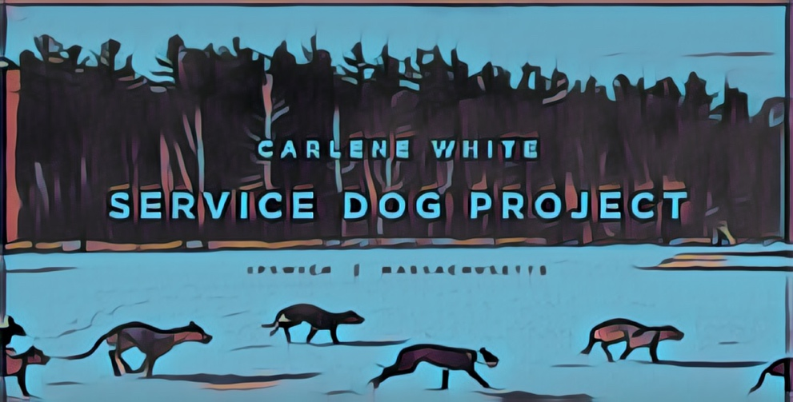
Last year, HYP launched a middle school summer trip program that took Hinesburg youth to the Berkshire Mountains for wilderness exploration and community service.

Prompted by an idea from our youth, this year’s middle school youth trip will travel to Ipswich, Massachusetts to volunteer at the Service Dog Project. Founded by Carlene White in 2003 on her 12-acre farm, the Service Dog Project breeds, raises, trains and matches certified Great Dane service dogs to individuals who have balance and mobility limitations due to Multiple Sclerosis, Parkinson’s Diseases, Cerebral Palsy, and traumatic injury. For more information on this organization, visit: https://www.servicedogproject.org.

Youth will work around the farm, caring for the dogs and learning about Carlene’s work. Youth will also have the opportunity for fun, exploring Massachusetts’ North Shore, local beaches and other activities. Finally, youth will travel to Canobie Lake Park in Salem, New Hampshire on the final day for fun and recreation.

The trip will take place Sunday, August 18th to Wednesday, August 21st and is open to all middle school students from Hinesburg.

Cost, Service and Fundraising Goals
Trip Fee: $250
$100 due April 14, 2019
$150 (or remaining balance) due June 1, 2019

All participating youth will participate in various fundraising and service projects throughout year. Aside from easing the total trip cost to families, youth work together for common causes, strengthening their bonds before the trip. Funds will be divided equally among those going. A schedule of fundraising events will be planned at the March 10, 2019 meeting.

Middle School Youth Trip Fundraising Goal: $2,000

